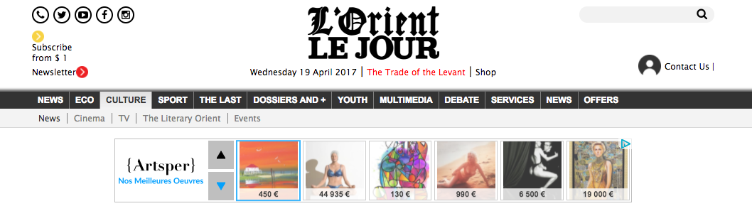
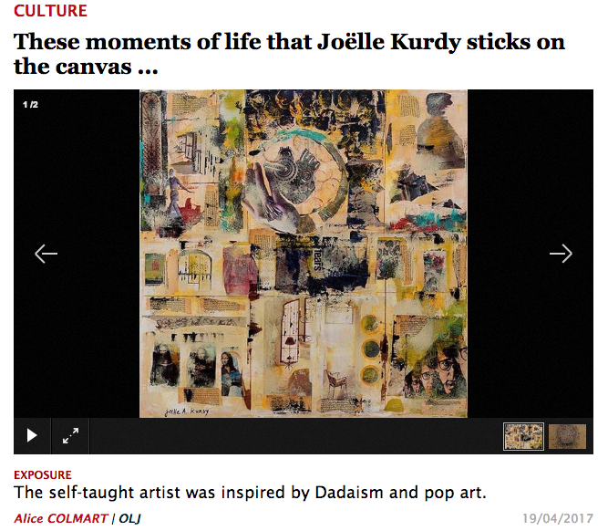

A self-taught artist, Joëlle Kurdy has been passionate about art since childhood: "My teachers exposed my paintings and drawings in class," she recalls proudly. Growing up, her interest did not falter: "Women spent their time buying jewelry. I spent my days visiting museums. After studying the art of make-up and body in Paris and Beirut, she embarked on artistic experimentation and explored different techniques. "I tried drawing, charcoal, ceramics, or painting on silk."
For the exhibition at the Art on 56th gallery, the artist was inspired by Dadaism and pop art. Wheel of Life mixes paint and photomontage. "I developed this taste very spontaneously, Explains the one who seeks to relay her everyday experiences in her work. "Many things have crumbled and broken in my life. Working with the collage allows me to reconstruct these complicated moments, pieces by piece. My paintings can take several months, depending on the periods and what I experienced. With humor, irony and cynicism, Joëlle Kurdy dedramatizes the difficult situations of life.
Working with the unknown
The artist follows his feeling and never knows how the work will evolve or what form it will take in the end. "I can start with plastic materials or crumpled paper, and end with pictures from magazines or acrylic," she says. The unknown, the intelligible pleases me. "
The female figure is recurrent in his work. "I think the woman has remarkable potential. She is love, she is generous. A life without her would be very sad. " The scene Scene of life, represents a muse bearing masculine biceps. "The daughter of Eve sometimes needs to take the role of man," explains the artist, who also discusses topics related to current events such as wars, Ecological or demographic problems such as overpopulation. "We live in a world where everything goes very quickly, where living beings no longer question themselves. Then the Earth turns inexorably and the wheel of life with.
For her second exhibition in Beirut, Joëlle Kurdy waits for visitors to pause and question their life experiences. "I wish them to be touched by my works and that these works help them to question themselves. She also hopes that they will give free rein to their imagination to detect, between two touches of color, those unspeakable things that they would not have thought of while drawing. Then the Earth turns inexorably and the wheel of life with. For her second exhibition in Beirut, Joëlle Kurdy waits for visitors to pause and question their life experiences. "I wish them to be touched by my works and that these works help them to question themselves. She also hopes that they will give free rein to their imagination to detect, between two touches of color, those unspeakable things that they would not have thought of while drawing. Then the Earth turns inexorably and the wheel of life with. For her second exhibition in Beirut, Joëlle Kurdy waits for visitors to pause and question their life experiences. "I wish them to be touched by my works and that these works help them to question themselves. She also hopes that they will give free rein to their imagination to detect, between two touches of color, those unspeakable things that they would not have thought of while drawing. They are touched by my works and they help them to question themselves. She also hopes that they will give free rein to their imagination to detect, between two touches of color, those unspeakable things that they would not have thought of while drawing. They are touched by my works and they help them to question themselves. She also hopes that they will give free rein to their imagination to detect, between two touches of color, those unspeakable things that they would not have thought of while drawing.

* Art on 56th Gallery
Gemmayze. Until April 29th.

